**Tugas: Membuat Stacked Bar**

- Download Source File: ramen-ratings.csv <https://github.com/joshuamlwn/tableau>

- Requirements: Create a Stacked Bar of the top 5 countries, with each country having its own style with its average star rating written on it.

The result should be like this:

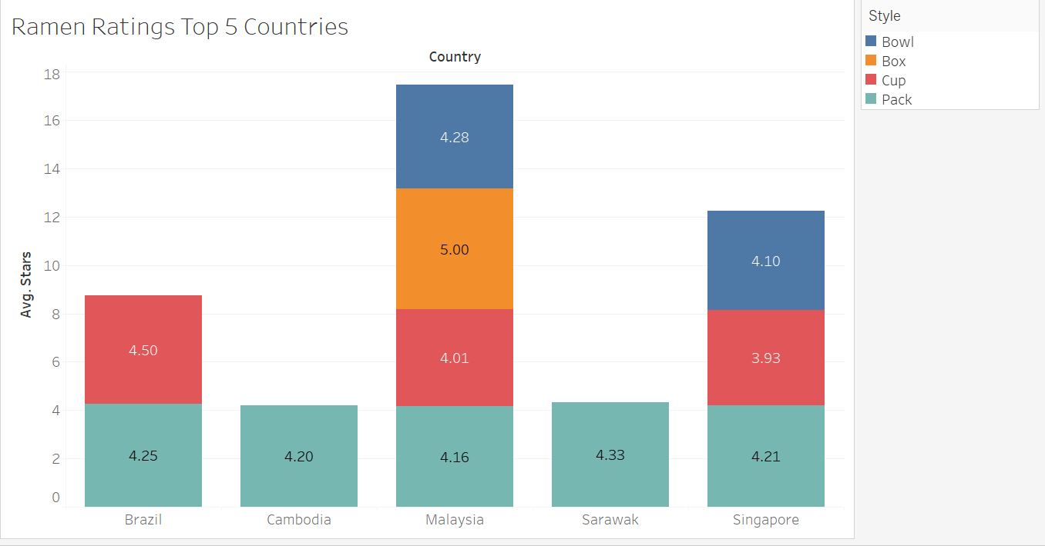

***Question: In which country, people like their ramen in a box ?***